**BASH scripting ASSIGNMENT 2**

**File test operators :**

**CODE :**

!/bin/sh

file="tf.sh"

if [ -r $fle ]

then echo File has read access

else echo File does not have read access

fi

if [ -x $file ]

then echo "File has execute permission"

else echo "File does not have execute permission"

fi

if [ -f $file ]

then echo "File is an ordinary file"

else echo "This is sepcial file"

fi

if [ -d $file ]

then echo "File is a directory"

else echo "This is not a directory"

fi

if [ -s $file ]

then echo "File size is zero"

else echo "File size is not zero"

fi

if [ -e $file ]

then echo "File exists"

else echo "File does not exist"

fi

**TEST FILE:**



**OUTPUT :**

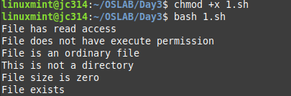

**Decision making :**

1. **if..else if.. else**

**CODE :**

#!/bin/bash

printf "Enter first number : "

read var1

printf "Enter second number : "

read var2

if [ $var1 == $var2 ]

then echo First number is equal to second number

elif [ $var1 -gt $var2 ]

then echo First number is greater than second number

elif [ $var1 -lt $var2 ]

then echo First number is less than second number

else echo None of the conditions met

fi

**OUTPUT:**

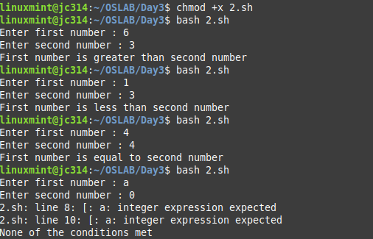

1. **case.. esac**

**CODE :**

#!/bin/sh

FRUIT="litchi"

case "$FRUIT" in

"apple") echo "Steve Jobs hated apples."

;;

"banana") echo "Bananas are cheap."

;;

"litchi") echo "Muzaffarpur litchis are dope."

;;

esac

**OUTPUT:**



**Unix-shell loops:**

1. **While loop:**

**CODE:**

#!/bin/bash

# prints first 5 numbers

echo While loop program that prints first five natural numbers

a=0

while [ $a -lt 5 ]

do printf "$(( $a + 1)) "

a=$(( $a + 1))

done

echo

**OUTPUT:**



1. **For loop:**

**CODE:**

#!/bin/bash

echo for loop program that prints first five natural numbers

for i in {1..5}

do printf "$i "

done

echo

**OUTPUT:**



1. **Until loop:**

**CODE:**

#!/bin/bash

echo until loop program that prints first five natural numbers

a=0

until [ $a -ge 6 ]

do printf "$a "

a=$(( $a + 1))

done

echo

**OUTPUT:**



1. **Select loop:**

**CODE:**

#!/bin/bash

echo demo select loop program that prints nth no of first five natural numbers

select i in {1..5}

do

case $i in

1) echo "First natural number"

;;

2) echo "Second natural number"

;;

3) echo "Third natural number"

;;

4) echo "Fourth natural number"

;;

5) echo "Fifth natural number"

;;

*) echo "Number not among first five natural numbers"

break

;;

esac

done

echo

**OUTPUT:**

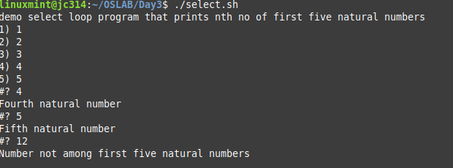

1. **Nested for loop in bash:**

**CODE:**

#!/bin/bash

for (( i=0; i <5; i++ )); do

for (( j=0; j <i; j++ )); do

printf "$j "

done

echo

done

**OUTPUT:**

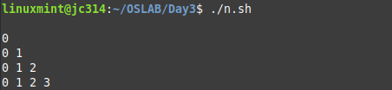

**Loop Control:**

1. **Infinite loop :**

**CODE:**

#!/bin/sh

echo The frigging infinite loop !!

a=1

while [ $a -lt 5 ]

do printf "$a "

done

**OUTPUT:**

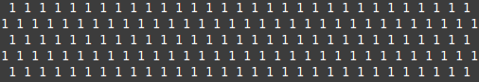

1. **Break statement:**

**CODE:**

#!/bin/sh

echo Loop breaks when variable is 5 !!

a=0

while [ $a -lt 10 ]

do

echo $a

if [ $a -eq 5 ]

then

break

fi

a=`expr $a + 1`

done

**OUTPUT:**

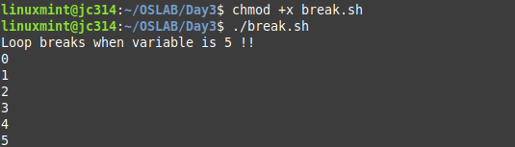

1. **Continue Statement:**

**CODE:**

#!/bin/sh

echo Loop breaks if both variables are 0

for var1 in 1 2 3

do

for var2 in 0 5

do

if [ $var1 -eq 2 -a $var2 -eq 0 ]

then

break 2

else

echo "$var1 $var2"

fi

done

done

**OUTPUT:**

